ISLAMIC UNIVERSITY OF TECHNOLOGY

Organization of Islamic Cooperation

Board Bazar, Gazipur

Laboratory Report

CSE 4512

**Title**: Configuration of OSPF in a network topology.

**Objective**:

* Describe the concept of OSPF and related terminologies
* Explain advantages of OSPF over RIP
* Configure OSPF in a network topology following given specifications

**Devices/Software Used**: Cisco Packet Tracer

**Theory**:

Link State (LS) Routing: In Link State Routing, each node has the entire topology of the domain, the list of nodes and links, how they are connected and even the type, cost and condition of the links. The nodes can then use Dijkstra’s Algorithm to generate a routing table. Each node only ever shares the details of its immediate neighbours, but it shares this knowledge with the entire domain.

Link-State Database (LSDB): This contains information about the topology, metrics, conditions, etc. about the different nodes in the network. It is shared amongst the different routers in the network.

Link State Packet: To send the information about the links with their neighbours, each node makes a Link State Packet. This packet contains information about each neighbour of the node and the cost of reaching the neighbour.

Open Shortest Path First (OSPF): The Open Shortest Path First (OSPF) protocol is an interdomain routing protocol based on Link State Routing.

Metric: This defines the cost of going to a particular hop from the current router. What this value depends on can vary. It could be the hop count, throughput, etc.

Autonomous System (AS): This is a collection of areas, a group of networks under a single administrative control. It controls how far the routing information should be propagated and facilitates filtering of information for sharing with other ASs. OSPF operates within a single AS.

Areas: An OSPF network is divided into areas, logical collections of routers and links having the same area ID. Each router in an area maintains the topological database for just the area it belongs to. Each area is also connected to a special area, called the backbone area or area 0, through which the areas communicate.

Area Border Router (ABD): This is a router with interfaces in two areas. It acts as the boundary between the two areas.

Designated Router (DR): On a multi-access network, like LAN, in each area, one router is elected as the Designated Router (DR). All the other routers in the area exchange routing information with just the DR instead of exchanging information with every router in the area. The DR then distributes topology information to every other router in the area. This greatly reduces OSPF traffic.

Link State Advertisement (LSA): This is the method used to communicate information in the OSPF protocol. There are several types of LSA, some working inside an area, some working between different areas and so on.

OSPF Implementation: This refers to how OSPF works overall. It includes the process distributing information about links between routers and also calculating the shortest paths to each node from a particular router.

OSPF Process ID: When enabling OSPF, a process ID must be mentioned. All the OSPF functions are then performed under that process. It is possible to have multiple OSPF processes running on the same router, but the routers under one OSPF must have the same process ID, since each OSPF process has its own database, topology table, etc. Multiple OSPF process IDs are provided to a single router only if the router is connected to multiple ASs.

Router ID in OSPF: Each router is assigned an ID which is unique within their AS. This is a 32-bit number that can be manually set using the router-id command. If not set manually, the highest loopback address is used. If a loopback address does not exist, the highest active IP address on any of the router’s interfaces is used.

Wildcard Mask: Unlike RIP, OSPF supports classless routing. This is where the wildcard mask comes in. A 0 bit in a wildcard mask means that the corresponding position in the IP address must match, while a 1 bit in a wildcard mask means that the corresponding position is irrelevant. Thus, for the command network 10.0.1.0 0.0.0.255 area 0, any interface with the IP address format 10.0.1.X will be advertised.

**Diagram of the experiment**:

Task #01:

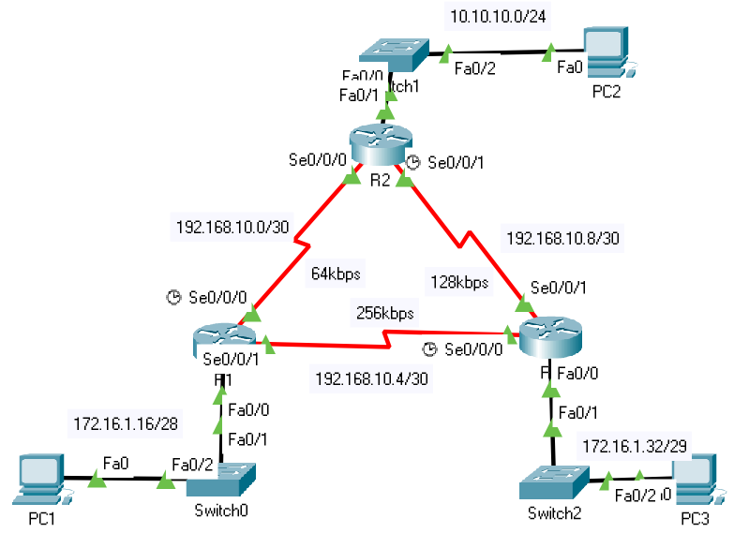

Task #02:

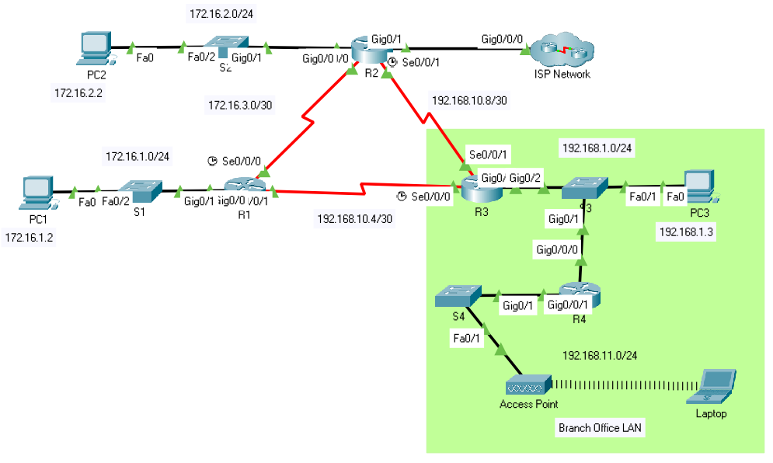

**Working Procedure**:

Task #01:

1. Router configuration:

R1:

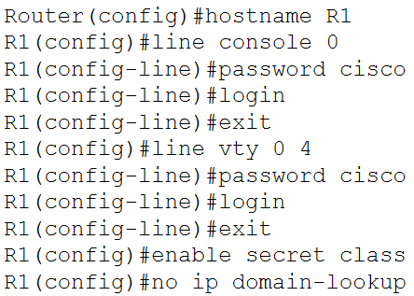

R2:

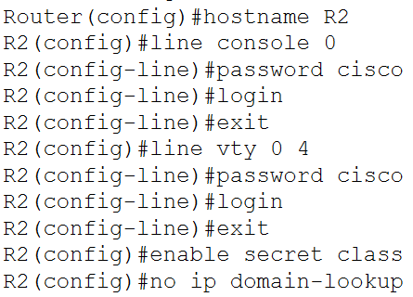

R3:

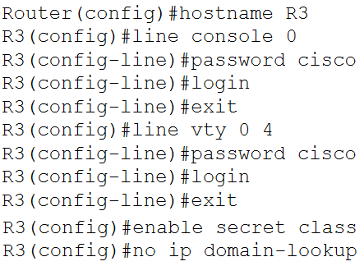

1. Configure interfaces:

R1:

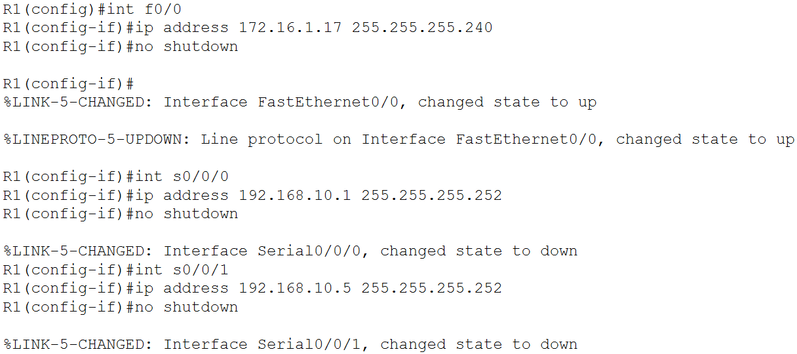

1. R2:

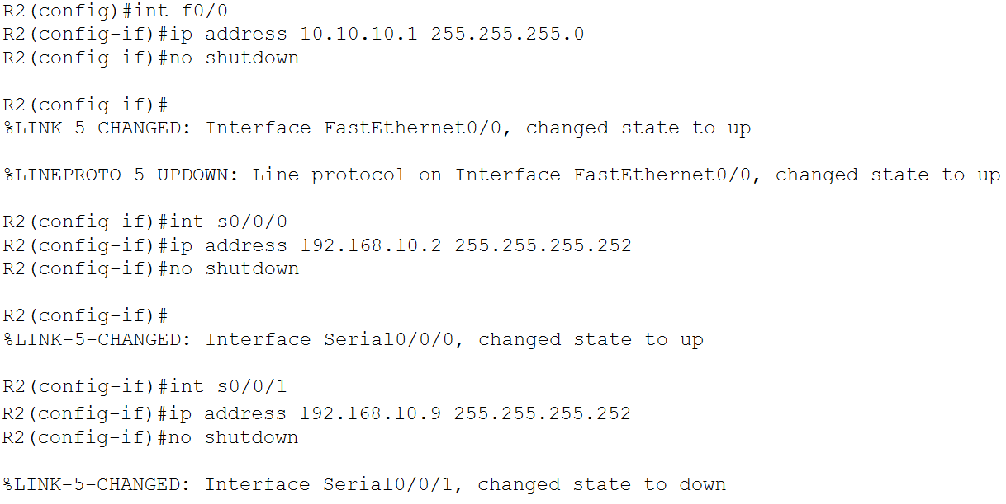

R3:

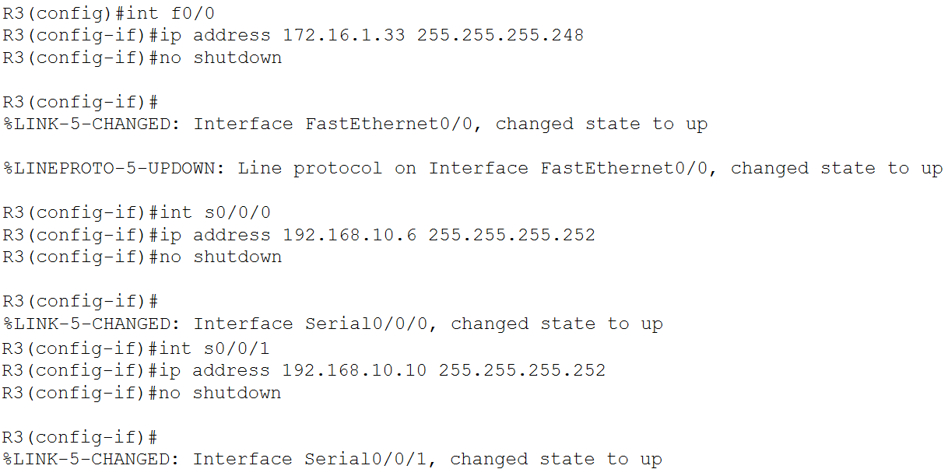

1. Verify IP addresses and interfaces:

R1:

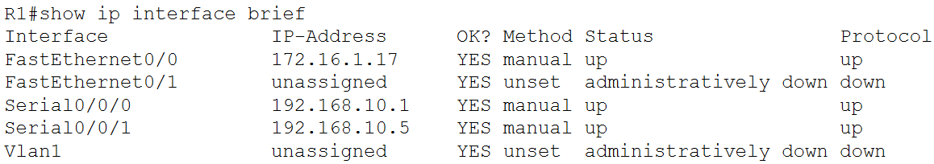

R2:

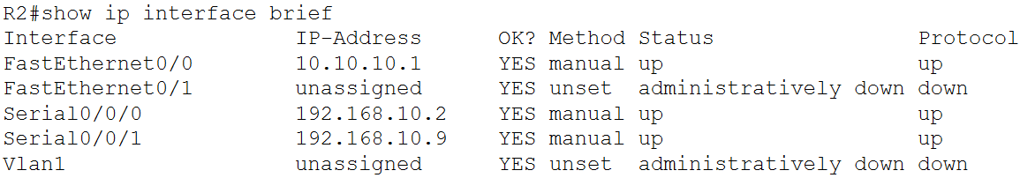

R3:

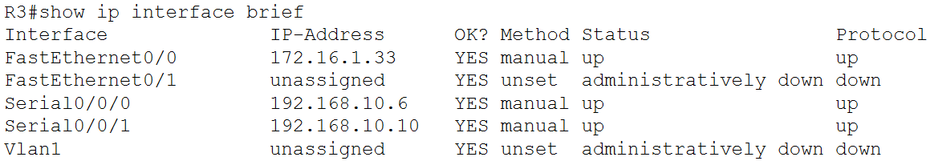

1. Configure ethernet interfaces of PCs:

PC1:

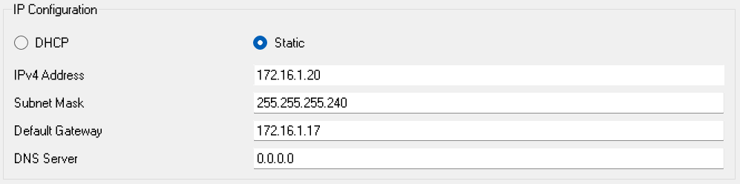

PC2:

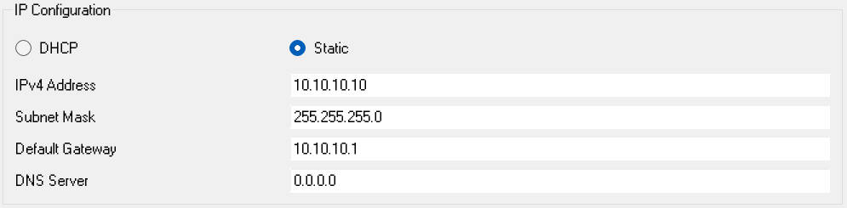

PC3:

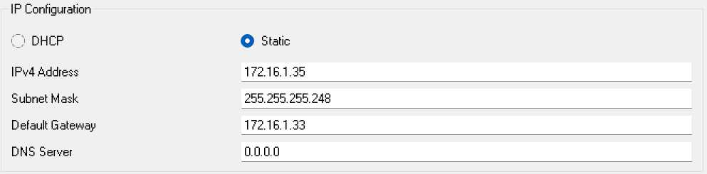

1. Configured OSPF on routers:

R1:

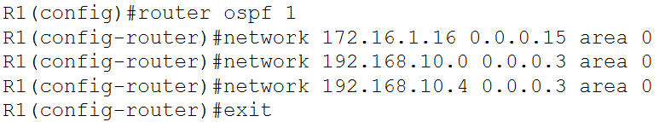

R2:

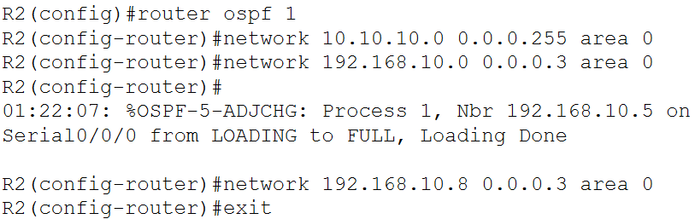

R3:

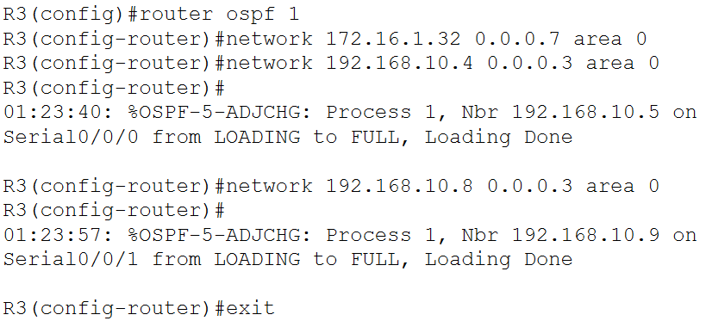

1. Examined router IDs:

R1:

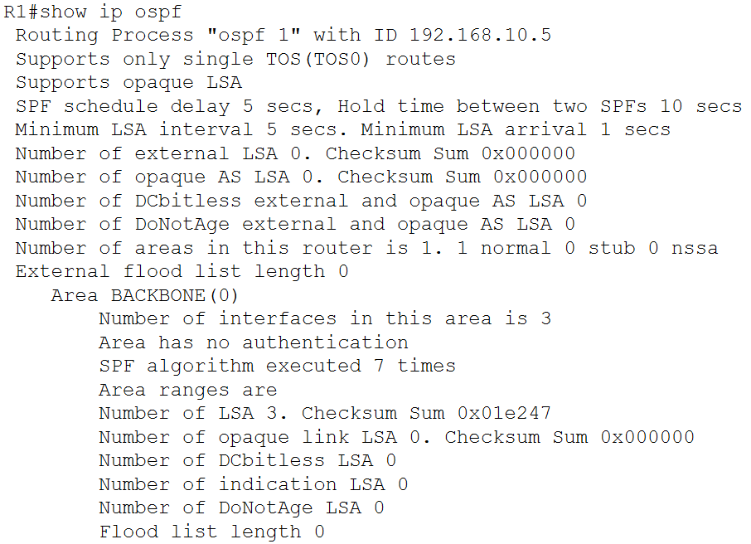

R2:

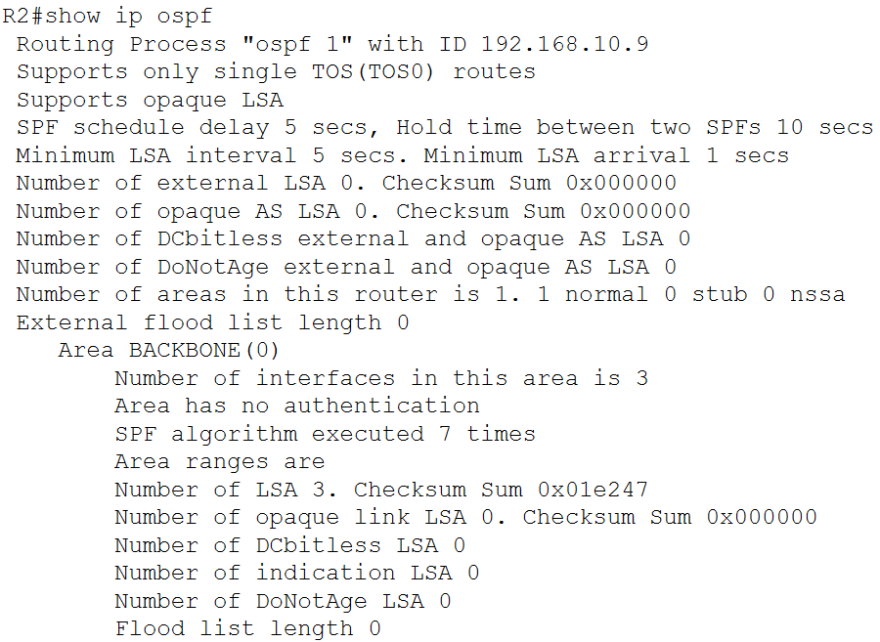

R3:

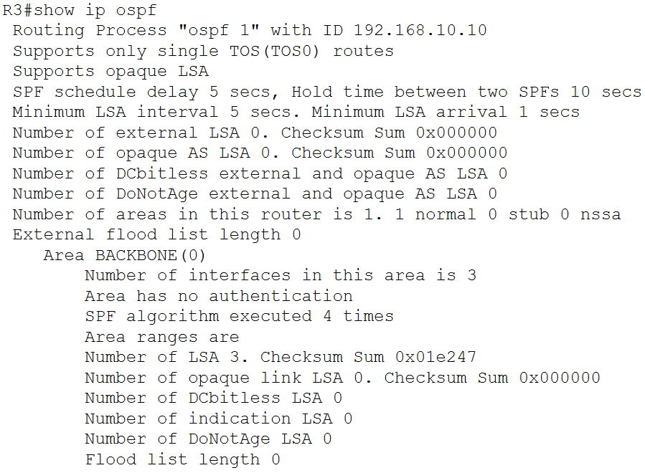

1. Loopback addresses were set for the routers:

R1:



R2:



R3:



1. The routers were restarted:

R1:

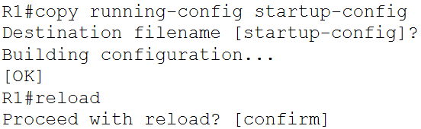

R2:

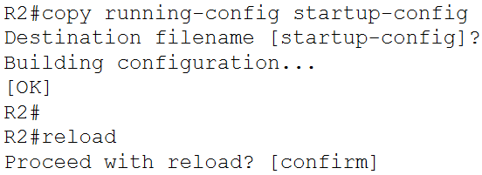

R3:

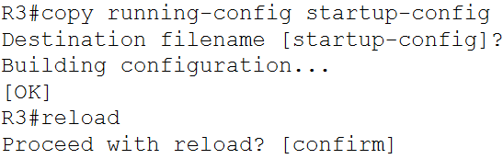

1. It was verified that the router IDs have changed:

R1:

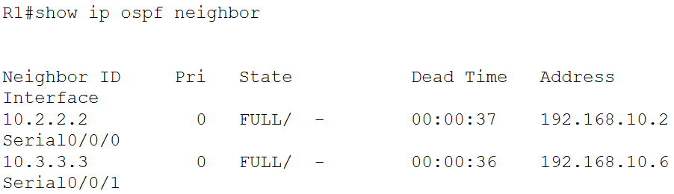

R2:

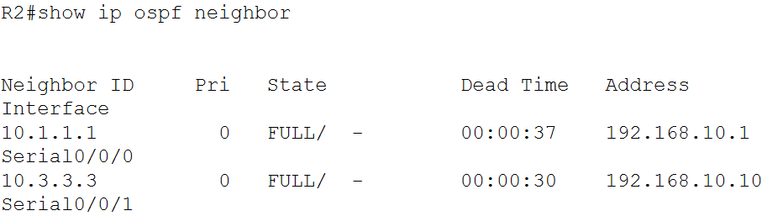

R3:

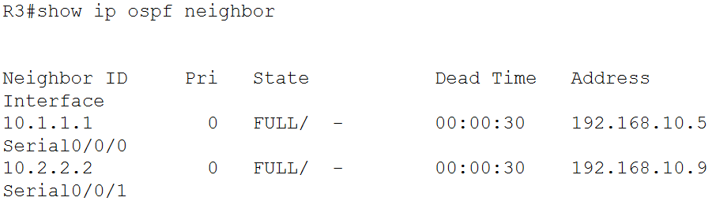

1. The router ID for R1 was changed:

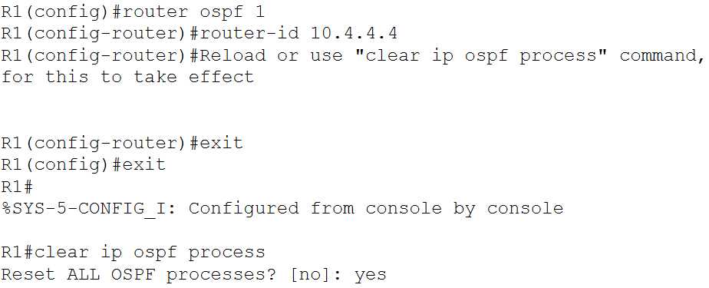

1. It was verified that the router ID of R1 has changed:

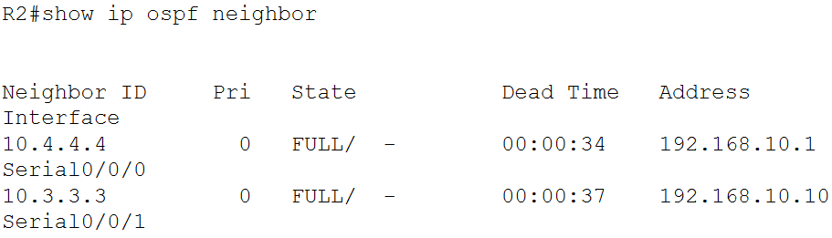

1. The configured router ID for R1 was removed:

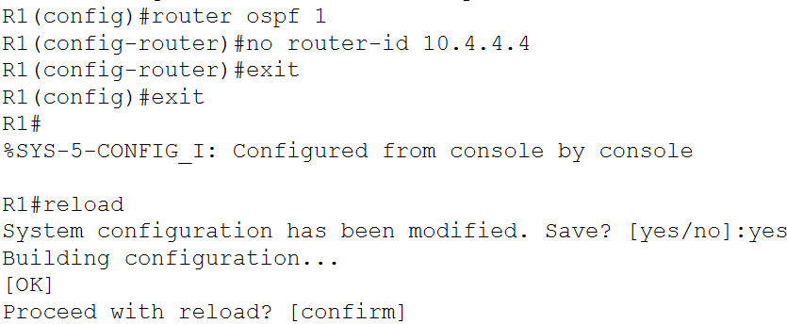

1. OSPF operation was verified:

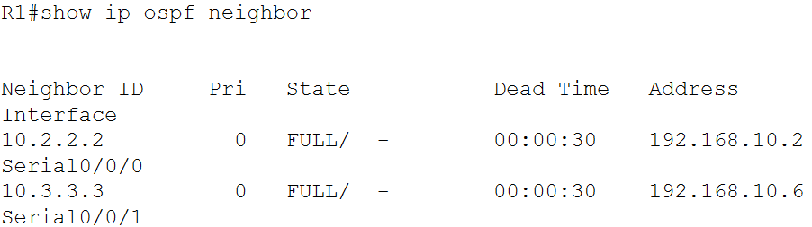

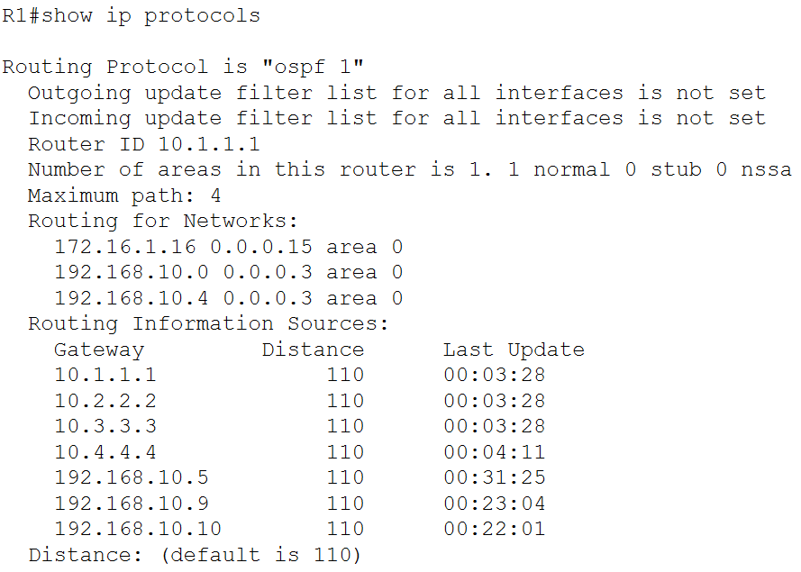



1. The routing table at R1 was viewed:

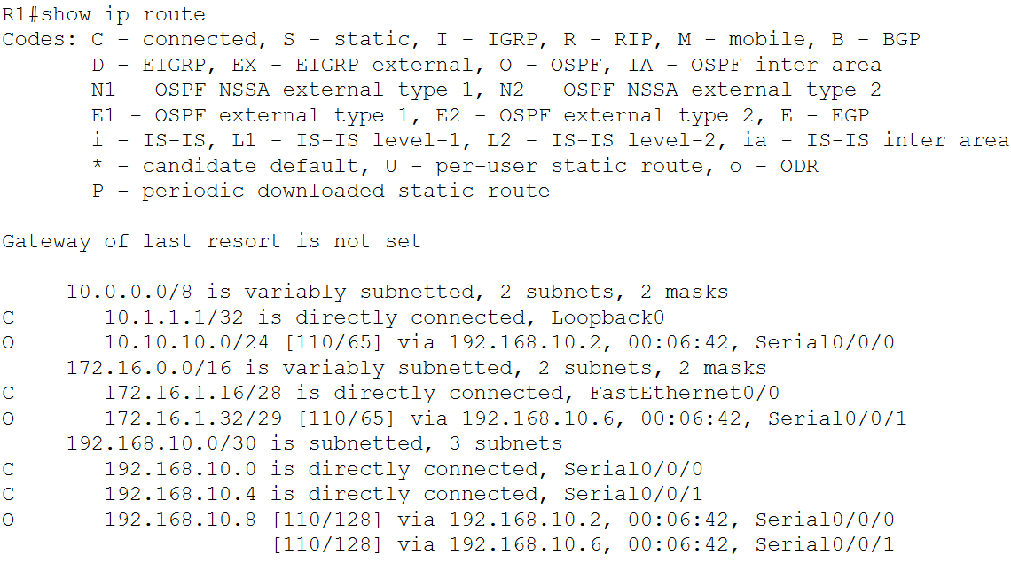

1. The cost of reaching the 10.10.10.0/24 network from R1 was viewed:

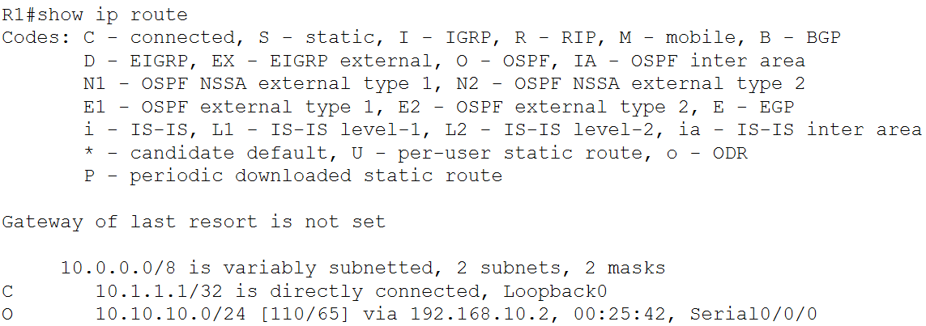

1. The bandwidth of the serial0/0/0 interface of R1 was viewed:

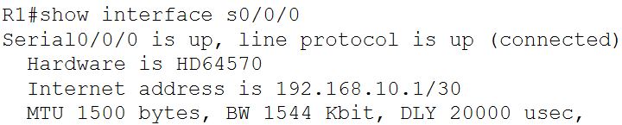

1. The bandwidths of the serial interfaces of R1 and R2 were changed:

R1:

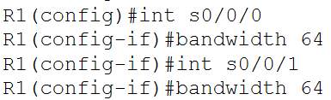

R2:

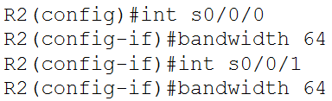

1. The cost of the serial links was verified from R1:

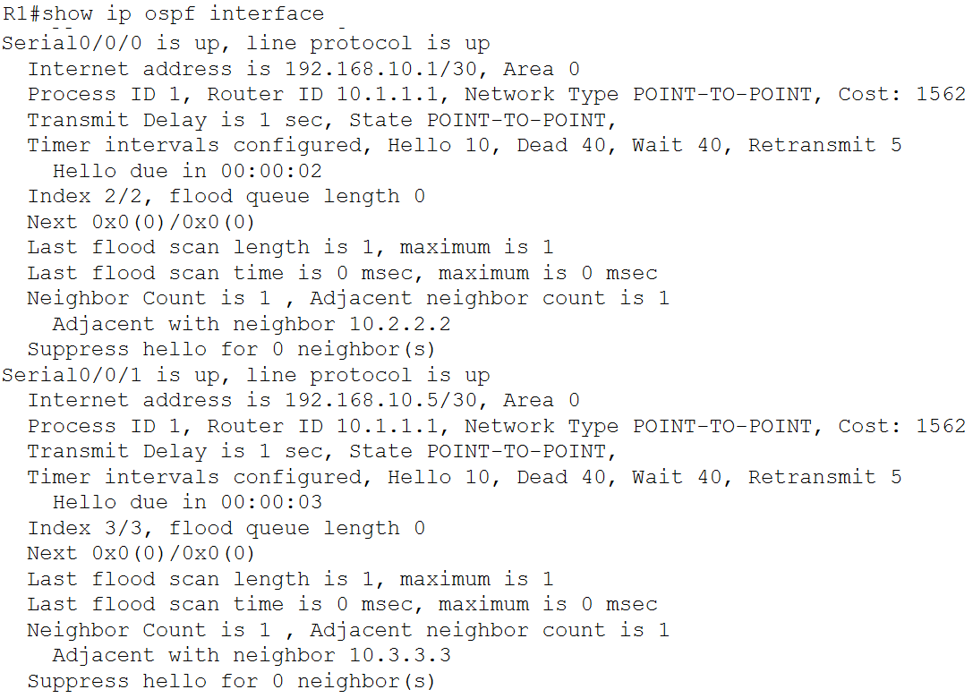

1. The OSPF cost on R3 was configured:

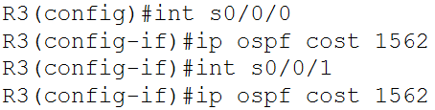

1. The OSPF cost on R3 was verified:

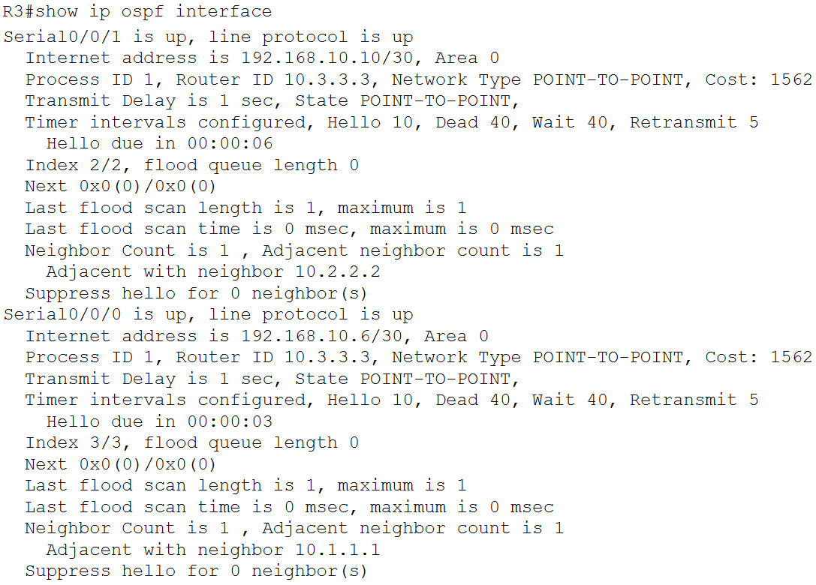

1. A loopback address was configured on R1 to simulate a link to an ISP:

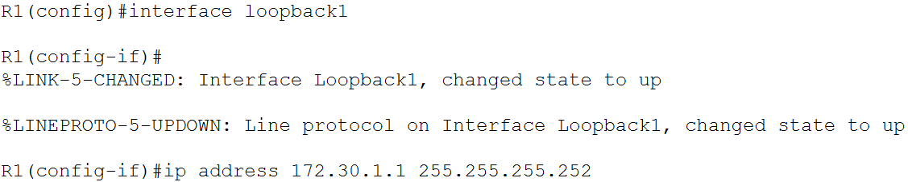

1. The loopback interface was configured as the static default route:



1. The static route was included in the OSPF updates:



1. It was verified from R2 that the static default route is being redistributed:

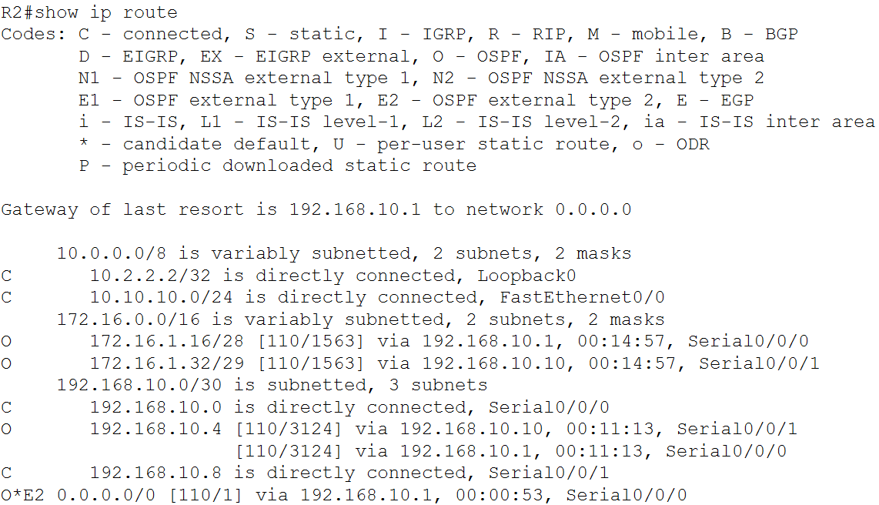

1. The reference bandwidth values on each of the routers was adjusted:

R1:



R2:



R3:



1. The change in the OSPF cost metric was verified from R1:

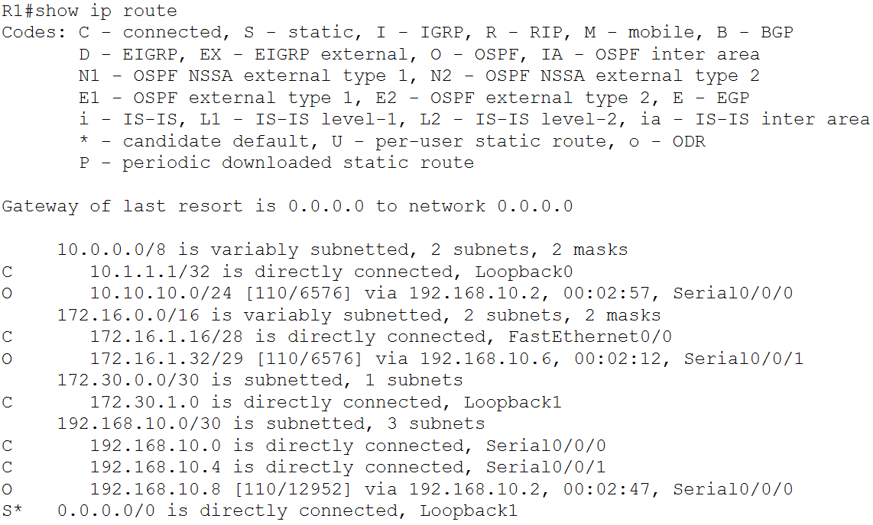

1. The dead time counter on R1 was viewed:

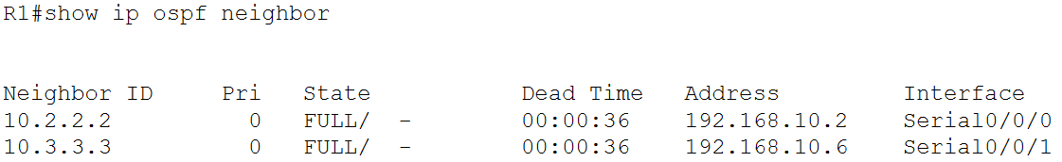

1. The OSPF hello and dead intervals for the serial 0/0/0 interface of R1 were configured:

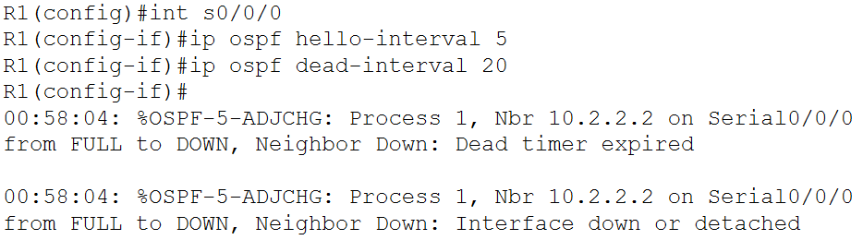

1. The OSPF hello and dead intervals for the serial 0/0/0 interface of R2 were configured:

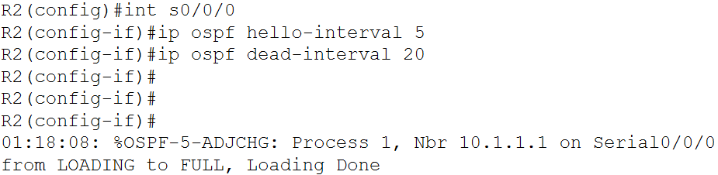

1. It was verified that the hello and dead intervals have been modified:

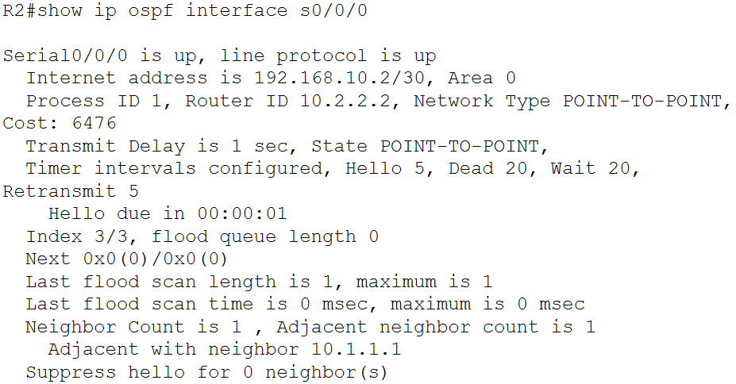

1. It was verified from R1 that the neighbour adjacency with R2 was restored:

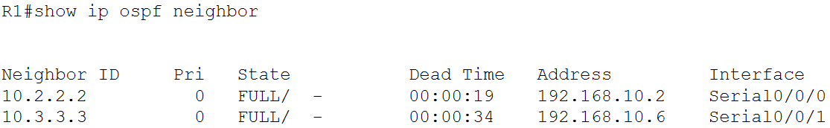

1. The clean-up stage was skipped.

Task #02:

1. Logged into R1 and executed the show ip route command:

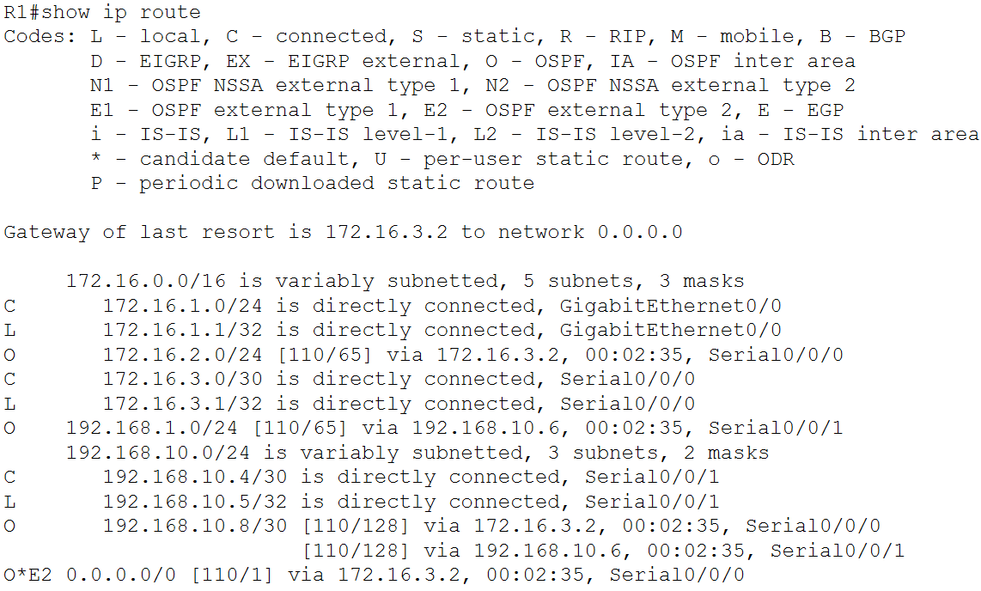

1. Executed the show ip ospf neighbor command on R1:

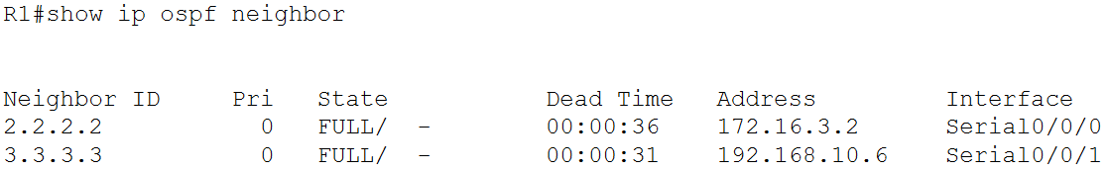

1. Pinged the ISP router from PC1:

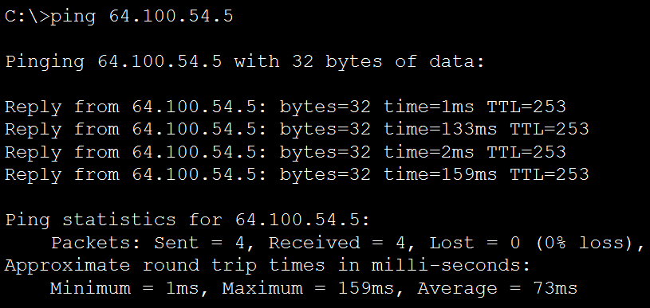

1. Logged into R2 and executed the show ip route command:

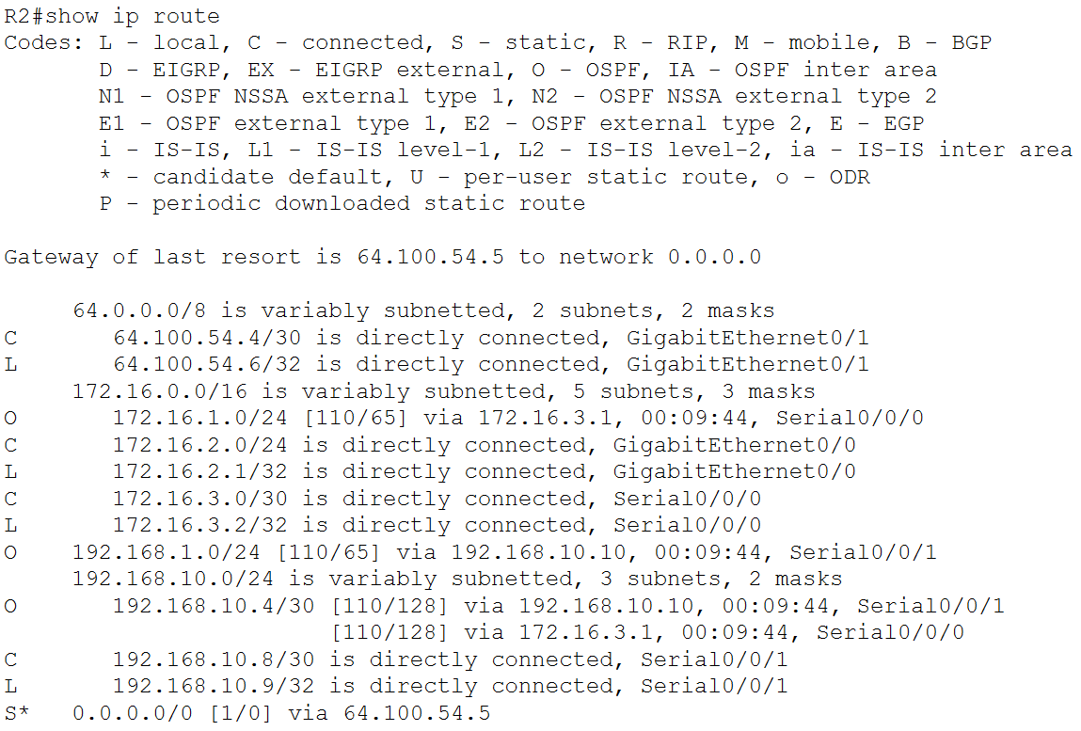

1. Executed the show ip ospf interface g0/0 command on R2:

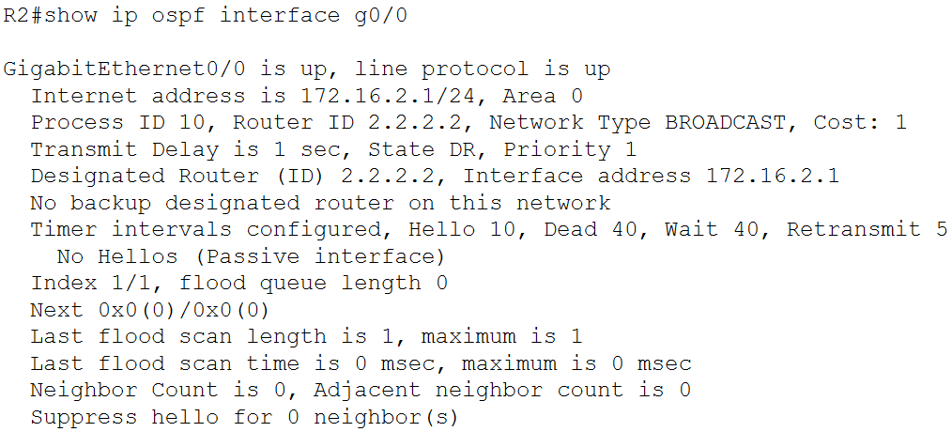

1. Pinged the S0/0/1 interface of R3 from PC2:

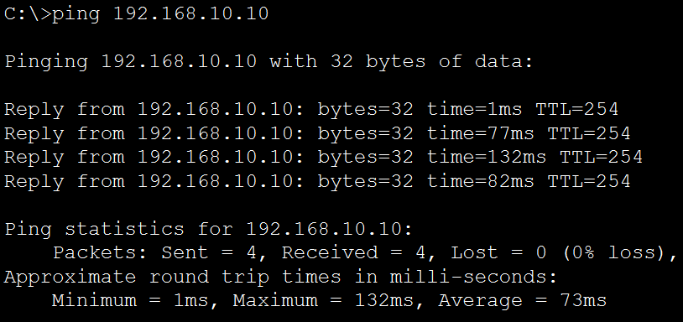

1. Executed the show ip protocols command on R3:

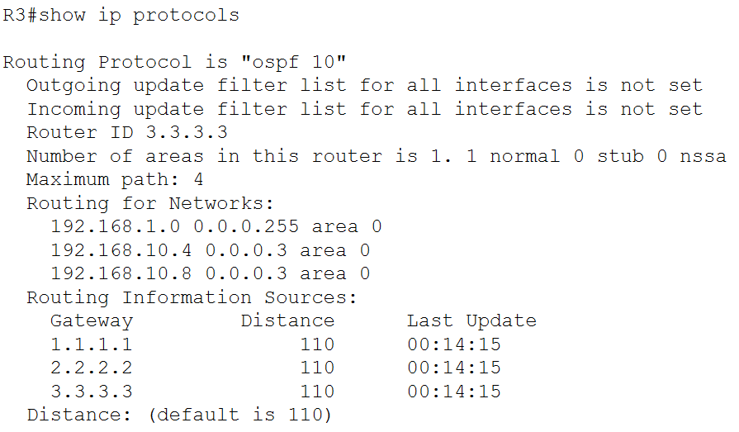

1. Executed the show ip ospf neighbor detail command on R3:

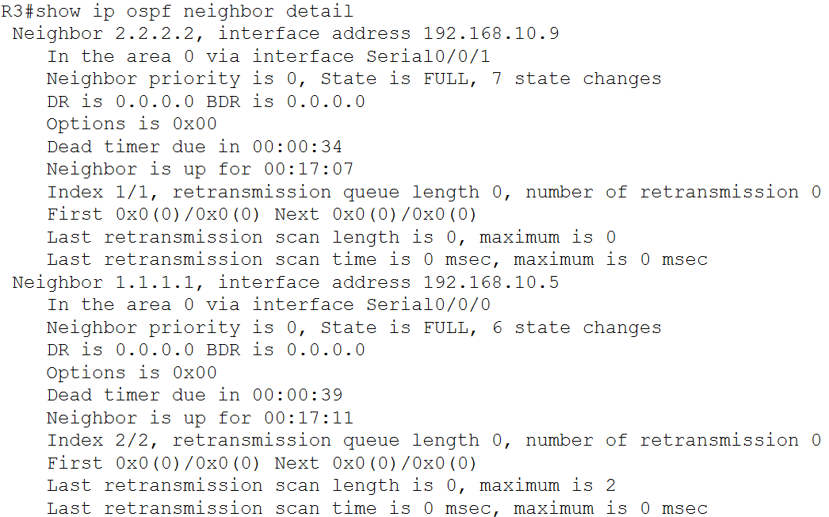



1. Pinged the ISP router from PC3:

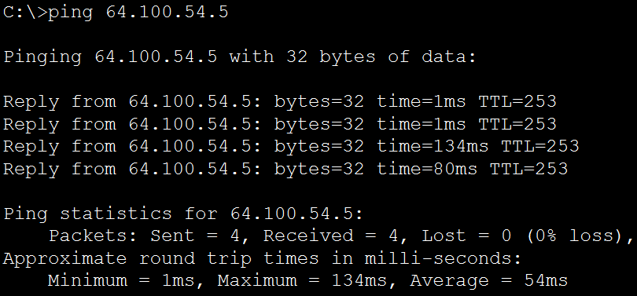

1. Executed the show run | begin router ospf command on R4:

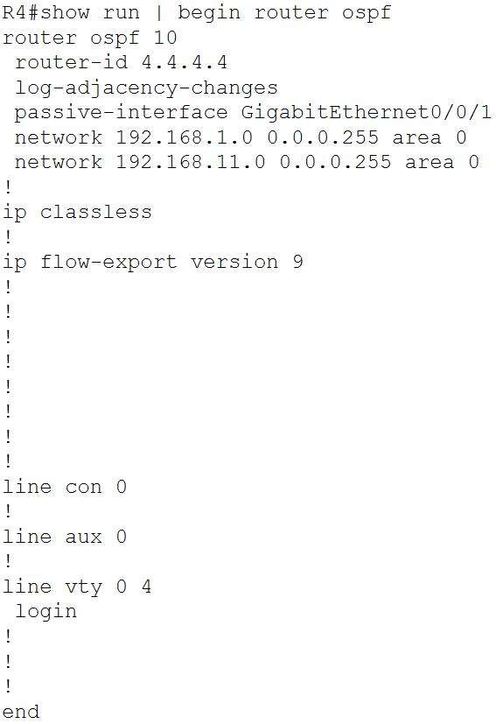



1. Connected R4 to S3 and executed the show ip ospf neighbor command on R4:

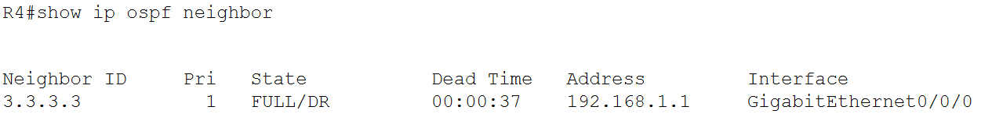

1. Executed the show ip ospf neighbor command on R3:

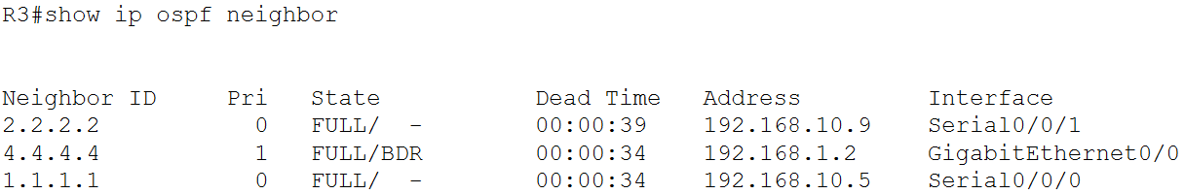

1. Pinged PC2 from Laptop:

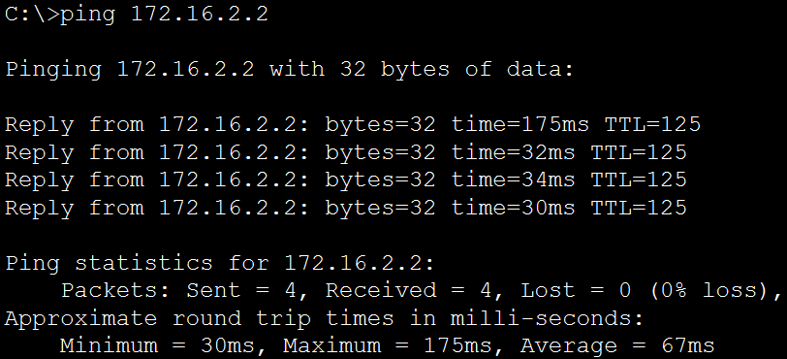

**Questions**:

TASK #01 - Part (Configure OSPF Router IDs) – Step 1:

Question: What is the router ID for R1?

Answer: 192.168.10.5

Question: What is the router ID for R2?

Answer: 192.168.10.9

Question: What is the router ID for R3?

Answer: 192.168.10.10

TASK #01 - Part (Configure OSPF Router IDs) – Step 3:

Question: When the router is reloaded, what is the router ID for R1?

Answer: 10.1.1.1

Question: When the router is reloaded, what is the router ID for R2?

Answer: 10.2.2.2

Question: When the router is reloaded, what is the router ID for R3?

Answer: 10.3.3.3

TASK #02 - Part 1 – Step 1:

Question: How did router R1 receive the default route?

Answer: It received the default route via OSPF from R2 through the S0/0/0 interface.

Question: From which router did R1 receive the default route?

Answer: R2.

Question: How can you filter the output of show ip route to show only the routes learned through OSPF?

Answer: We can use the show ip route ospf command.

Question: Which routers have formed adjacencies with router R1?

Answer: R2 and R3.

Question: What are the router IDs and state of the routers shown in the command output?

Answer: The router IDs are 2.2.2.2 and 3.3.3.3 and the state is Full/- for both routers.

Question: Are all of the adjacent routers shown in the output?

Answer: Yes.

TASK #02 - Part 1 – Step 2:

Question: How did router R2 learn the default route to the ISP?

Answer: It learnt the default route via static configuration.

Question: What type of OSPF network is attached to the interface g0/0 of R2?

Answer: BROADCAST

Question: Are OSPF hello packets being sent out this interface? Explain.

Answer: No. This is a passive interface.

TASK #02 - Part 1 – Step 3:

Question: Router R3 is routing for which networks?

Answer: 192.168.1.0/24, 192.168.10.4/30 and 192.168.10.8/30.

Question: What is the neighbour priority shown for the OSPF neighbour routers?

Answer: 0

TASK #02 - Part 2 – Step 1:

Question: Which interface of R4 is configured to not send OSPF update packets?

Answer: GigabitEthernet0/0/1

TASK #02 - Part 2 – Step 2:

Question: What state is displayed for router R3?

Answer: FULL/DR

Question: Why is the state of router R4 different than the state of R1 and R2?

Answer: In OSPF, for multi-access networks, if there are multiple routers in the same segment, one router is elected as the DR while another is elected as the BDR. R3 and R4 are in the same segment, and since R3 was already the DR, R4 was elected as the BDR. R1 and R2 do not qualify for this, since they are in a point-to-point network.

**Challenges**:

The length of the first task led to some confusion towards the end.

The last question for the second task presented a bit of a challenge since the concept was new and thus took a while to understand.